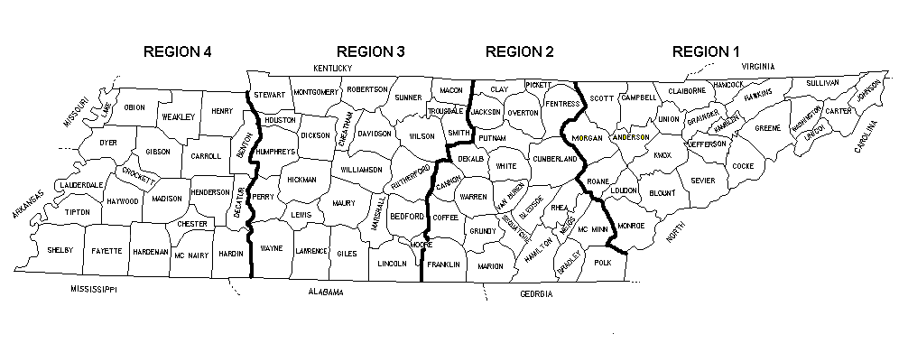
REGIONS OF THE TENNESSEE DEPARTMENT OF TRANSPORTATION
21 COUNTIES IN REGION 4
Region 4 Office - Jackson
03 - Benton
09 - Carroll
12 - Chester
17 - Crockett
20 - Decatur
23 - Dyer
24 - Fayette
27 - Gibson
35 - Hardeman
36 - Hardin
38 - Haywood
39 - Henderson
40 - Henry
48 - Lake
49 - Lauderdale
55 - McNairy
57 - Madison
66 - Obion
79 - Shelby
84 - Tipton
92 - Weakley
26 COUNTIES IN REGION 3
Region 3 Office - Nashville
02 - Bedford
11 - Cheatham
19 - Davidson
22 - Dickson
28 - Giles
41 - Hickman
42 - Houston
43 - Humphreys
50 - Lawrence
51 - Lewis
52 - Lincoln
56 - Macon
59 - Marshall
60 - Maury
63 - Montgomery
64 - Moore
68 - Perry
74 - Robertson
75 - Rutherford
80 - Smith
81 - Stewart
83- Sumner
85 - Trousdale
91 - Wayne
94 - Williamson
95 - Wilson

24 COUNTIES IN REGION 2
Region 2 Office - Chattanooga
04 - Bledsoe
06 - Bradley
08 - Cannon
14 - Clay
16 - Coffee
18 - Cumberland
21 - DeKalb
25 - Fentress
26 - Franklin
31 - Grundy
33 - Hamilton
44 - Jackson
54 - McMinn
58 - Marion
61 - Meigs
67 - Overton
69 - Pickett
70 - Polk
71 - Putnam
72 - Rhea
77 - Sequatchie
88 - Van Buren
89 - Warren
93 - White

24 COUNTIES IN REGION 1
Region 1 Office - Knoxville
01 - Anderson
05 - Blount
07 - Campbell
10 - Carter
13 - Claiborne
15 - Cocke
29 - Grainger
30 - Greene
32 - Hamblen
34 - Hancock
37 - Hawkins
45 - Jefferson
46 - Johnson
47 - Knox
53 - Loudon
62 - Monroe
65 - Morgan
73 - Roane
76 - Scott
78 - Sevier
82 - Sullivan
86 - Unicoi
87 - Union
90 - Washington

